# Question 3

|  |  |  |  |
| --- | --- | --- | --- |
| 1. Do charities which seek to help the public engage more with Twitter to reach the public? | - Table of public facing chars  - Possibly summary of income and other for public and non-public  - Summary of followed on Twitter | - | - Linear followed on Twitter with public facing and income control  - Inverse logit with following predicted public facing? |

## Univariate

|  |  |  |
| --- | --- | --- |
|  | **Helps the general public** | **Does not help general public** |
| n | 5528 | 5272 |
| % | 51.2 | 48.8 |

The table above summarises the binary ‘Helps the general public’ variable which records if a charity seeks to help the general public or a more focused group (such as other charities, animals, etc.). Charities such as educational trusts are also usually excluded from this group. Roughly half of the sample is in each category.

**Does not help general public**

|  |  |  |  |
| --- | --- | --- | --- |
|  | **Income 2018** | **Proportion of general public funding** | **Twitter followers** |
| **Count** | 4612 | 5747 | 1976 |
| **Mean** | 1407509 | 0.014 | 2735 |
| **Std** | 1687574 | 0.029 | 3358 |
| **Median** | 758100 | 0 | 1508 |
| **Min** | 0 | -0.046 | 0 |
| **Max** | 7400000 | 0.151 | 17324 |

**Just charities which help general public**

|  |  |  |  |
| --- | --- | --- | --- |
|  | **Income 2018** | **Proportion of general public funding** | **Twitter followers** |
| **Count** | 4846 | 5544 | 2218 |
| **Mean** | 1297389 | 0.018 | 3788 |
| **Std** | 1622773 | 0.034 | 4118 |
| **Median** | 664300 | 0 | 2134 |
| **Min** | 0 | -0.024 | 0 |
| **Max** | 7400000 | 0.151 | 17446 |

The summary tables above are split by the binary ‘Helps the general public’ variable to show how these groups differ in terms of funding and popularity on Twitter. As shown, charities which do help the general public tend to have slightly lower incomes, but gain more of their income from public funding. Most importantly they appear to have more followers on Twitter, but this will be fully explored in the modelling.

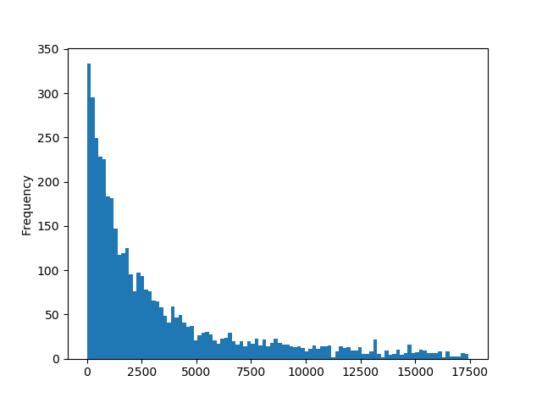

This histogram shows the distribution of twitter followers after it had been treated for outliers. The distribution is half normal but is not overly afflicted with outliers and should be suitable for modelling.

## Multivariate modelling

|  |  |  |  |
| --- | --- | --- | --- |
| **Dependent**: Twitter followers | **Coef.** | **Std error** | **P>|t|** |
| Helps general public | 1193 | 121 | 0.000 |
| Income 2018 | 0.000 | 0.000 | 0.000 |
| Constant | 1632 | 110 | 0.000 |

R-squared 0.064 Prob = 0.000 AIC =68230 BIC =68250

This first model is an OLS model which predicts number of Twitter followers (popularity) based on whether the charity helps the general public. Income is included as a control for size which usually has a large effect on Twitter popularity. Both the primary independent and the control are significant in this model. The primary is binary which means the result of 1193 means that charities which help the general public, on average, have 1193 more twitter followers than those who do not – controlling for size. This suggests public facing charities may be more likely to maintain a popular twitter account to engage with the public.